Hormozi Framwork

Casually selfie video - Referrals are risky Reframe
"If you want to start closing more reverse mortgage deals, you basically have two options.
You could go the referral route — connect with more financial advisors, more realtors, more estate attorneys, hoping they send you business. Or you could take those same limited resources — your time, your money — and actually invest them into building a marketing system.
So which one do you choose?
And the thing is — that question right there is why most loan officers stay stuck, since there’s not necessarily a right answer. Because one path feels safe and familiar. And the other feels like a risk. And so what ends up happening is most LOs default to what they know. What feels comfortable. Which is referrals.
You see, it's not that the referral model doesn't work. It does. But here's the thing. Thinking referrals alone are going to give you the business you actually want– is a self-fulfilling prophecy.
Because here's why it feels less risky. When you go the referral route, you don't see money leaving your wallet. There's no invoice. No line item. So it doesn't feel like a cost. But you're still paying. You're just paying it inconsistently. In slow months. In the commissions you could've been making but weren't. That cost is invisible — but over a year, it's massive.
Now on the other side — paid acquisition feels expensive because you can see it. Right? There's a real number. And I understand why that's scary. Especially in this industry.
Beca
use the biggest risk with paid ads isn't whether ads work. There are loan officers spending thousands every month on this right now — so clearly the market is there. The real risk is finding the system that actually works. And most LOs in this space have been burned. Bad agencies. Bad lead gen companies. Ads that ran with no strategy, no follow-up, no back-end infrastructure. Just a form and a prayer.
And that experience leaves people making decisions out of fear. And I don't blame them. I get it.
But here's what most people don't realize. The reason those campaigns failed wasn't the platform. It wasn't the market. It was that the ads were built wrong, and there was nothing behind them. Because getting someone to fill out a form is not the goal. The goal is getting a qualified person, inbound, already educated, already interested — who actually wants to speak to you. That's a completely different thing.
And that's the difference between a lead and an acquisition system.
So here's the framework I'd leave you with. Referrals are income. They're not an asset. You can't scale them. You can't predict them. And the moment a key partner slows down or moves on, your pipeline moves with them. You don't own it. You're renting it.
Paid acquisition, built correctly, is something you own. You control the volume. You control the timing. You turn it up when you need more. And unlike referrals — it compounds. The longer it runs, the more data it has, the better it performs.
The top producers in this space didn't get there by adding more referral partners. They got there by building something they control. They just stopped paying the invisible price and started investing in the system that actually moves the needle.
So if you're at that point — where the ceiling keeps showing up no matter how many relationships you build — click below. Let's get on a call, see if what we've built makes sense for where you are. And if it does, love to show you exactly how it works."

—----

There's a question almost every loan officer in this space is asking right now.
"Should I keep working my referral network — or invest in a real marketing system?"
And that question right there is exactly why most reverse mortgage LOs stay stuck.
Because it's the wrong question.
You're not choosing between two strategies. You're choosing between a cost you can see — and a cost you've been ignoring.
Here's what nobody talks about:
Referrals aren't free.
Every slow month waiting for a partner to send you something — that's a cost. Every deal that didn't come because your key referral source had a bad quarter — that's a cost. Every morning you woke up with no idea what was coming in this week — that's a cost. It just never showed up on an invoice.
So when loan officers tell me paid ads feel risky — I get it. The cost is visible. You can see exactly what you're spending.
But here's the real risk:
It's not the platform. It's not the market. It's not even the rates.
The real risk is running a business where your pipeline lives inside someone else's relationship — and the day that relationship slows down, cools off, or walks out the door, you have nothing behind it.
That's not a bad month. That's a structural problem.
Now — most LOs who tried ads before got burned. I know that. And I'm not going to tell you those experiences weren't real.
But here's what actually happened:
A generalist agency ran a stock image ad to a cold audience with no education, no follow-up system, and no understanding of why a 67-year-old homeowner doesn't trust the words "reverse mortgage" the first time they see them.
That's not a Facebook problem. That's not a leads problem.
That's a system problem.
Because getting someone to fill out a form is not the goal. The goal is a pre-educated, pre-qualified prospect who already understands what this product does — showing up on your calendar, ready to have a real conversation.
That's the difference between buying leads and building an acquisition engine.
One is income. The other is an asset.
Referrals are income. They pay you when they come in. But they don't compound. You can't scale them. You can't turn them up when you need volume. And you can't hand them to someone else when you're ready to grow.
The top producers in this space — the ones closing consistently regardless of what the market is doing — they didn't get there by waiting for the phone to ring.
They built something they own.
If you're at that point — where the referral ceiling keeps showing up, where the pipeline feels like it's always one relationship away from a problem — click the link, book a call.
We'll show you exactly what the system looks like. And you can decide if it's the right move.

—-
Most loan officers think referrals are free.
They're not. You're just paying a price that doesn't show up on an invoice.
Here's what I mean.
If you want to start closing more reverse mortgage deals, you basically have two options. You could go the referral route — connect with more financial advisors, more realtors, more estate attorneys, hoping they send you business. Or you could take those same limited resources — your time, your money — and actually invest them into building a marketing system.
So which one do you choose?
And that question right there is exactly where most loan officers get stuck.
Because one path feels safe and familiar. And the other feels like a risk. So most LOs default to what they know. What feels comfortable. Which is referrals.
And here's the thing — it's not that the referral model doesn't work. It does. But thinking referrals alone are going to give you the business you actually want is a self-fulfilling prophecy.
Because here's why it feels less risky. When you go the referral route, you don't see money leaving your wallet. There's no invoice. No line item. So it doesn't feel like a cost.
But you're still paying.
You're just paying it inconsistently. In slow months. In the commissions you could've been making but weren't. That cost is invisible — but over a year, it's massive.
Now on the other side — paid acquisition feels expensive because you can see it. There's a real number. And I understand why that's scary. Especially in this industry.
Because the biggest risk with paid ads isn't whether ads work. There are loan officers spending thousands every month on this right now — so clearly the market is there.
The real risk is the system behind them.
And most LOs in this space have been burned. Bad agencies. Bad lead gen companies. Ads that ran with no strategy, no follow-up, no back-end infrastructure. Just a form and a prayer.
And that experience leaves people making decisions out of fear. I get it.
But here's what most people don't realize. The reason those campaigns failed wasn't the platform. It wasn't the market. It was that the ads were built wrong — and there was nothing behind them.
Because getting someone to fill out a form is not the goal.
The goal is a pre-educated, pre-qualified prospect who already understands what this product does — showing up on your calendar, ready to have a real conversation. That's a completely different thing.
And that's the difference between a lead and an acquisition system.
So here's the framework I'd leave you with.
Referrals are income. They're not an asset. You can't scale them. You can't predict them. And the moment a key partner slows down or moves on, your pipeline moves with them. You don't own it. You're renting it.
Paid acquisition, built correctly, is something you own. You control the volume. You control the timing. You turn it up when you need more. And unlike referrals — it compounds. The longer it runs, the more data it has, the better it performs.
The top producers in this space didn't get there by adding more referral partners. They got there by building something they control. They stopped paying the invisible price — and started investing in the system that actually moves the needle.
So if you're at that point — where the ceiling keeps showing up no matter how many relationships you build — click below.
Let's get on a call and show you exactly what the system looks like.

Foward LO Angle

Ad Approach

Ad Script: "How Many Forward Deals Would That Take You?"PRODUCTION NOTES
Direct-to-camera. Outdoor or clean indoor background. Casual but confident. Fast cuts every 3-5 seconds. Bold text overlays on every key stat. Energetic but not salesy — this feels like a friend telling you something real. Speaker is ideally Pedro or a producing LO in the program.

SCRIPT

[HOOK — 0:00–0:08]
Fast cut. Direct to camera. Slightly leaning in. Urgent tone.
SPEAKER:
"Last month, One of the loan officers in our program closed a loan last month — and walked away with $33,000 in commission from that single deal."
🖥️ ON SCREEN: $33,000. ONE DEAL. ONE MONTH. (bold red or white, fast flash)
And i’ve help over dozens of LO’s

[PATTERN INTERRUPT — 0:08–0:18]
Pause. Slight smirk. Let it land.
SPEAKER:
"Now let me ask you something. If you're doing forward mortgages right now — how many deals would it take you to make $32,000?"
🖥️ ON SCREEN: HOW MANY DEALS WOULD THAT TAKE YOU?
Beat.
SPEAKER:
"Five? Six? Maybe more — if they even close."
🖥️ ON SCREEN: 5... 6... IF THEY EVEN CLOSE (each number flashes separately)

[PAIN — 0:18–0:45]
Tone shifts. More serious. Empathetic. This is the "I see you" moment.
SPEAKER:
"Look — if you're a forward LO right now, I already know what your market looks like."
🖥️ ON SCREEN: THE FORWARD MORTGAGE MARKET RIGHT NOW 👇
SPEAKER:
"Rates are sitting at 7%. Your refi pipeline? Gone. Completely dried up."
🖥️ ON SCREEN: REFIS: DEAD ❌
SPEAKER:
"60 to 70% of homeowners are locked into rates below 4% — they are not moving. They have zero reason to sell."
🖥️ ON SCREEN: 60-70% OF HOMEOWNERS LOCKED BELOW 4%
SPEAKER:
"So you're fighting — every single day — over the same shrinking pool of buyers. Competing on basis points. Chasing Realtors who are just as stressed as you are. Working just as hard as you did in 2021..."
Pause. Direct eye contact.
SPEAKER:
"...for a fraction of the income."
🖥️ ON SCREEN: INCOME DOWN 60-70% 📉 (slow fade in for impact)

[PIVOT — 0:45–1:05]
Energy shifts upward. This is the turn. Lean in.
SPEAKER:
"But here's what nobody in your world is talking about."
🖥️ ON SCREEN: WHAT NOBODY IS TELLING YOU ⬇️
SPEAKER:
"While you're swimming upstream in the most brutal forward mortgage market in a decade — there is a completely different market sitting right next to you. Wide open. Almost zero competition."
🖥️ ON SCREEN: BLUE OCEAN. ZERO COMPETITION.
SPEAKER:
"Reverse mortgages."
🖥️ ON SCREEN: REVERSE MORTGAGES (bold, centered, held for 2 seconds)
Anticipate the eye-roll. Address it immediately.
SPEAKER:
"And before you scroll — just hear the numbers."

[DATA DROP — 1:05–1:30]
Fast pace. Confident. Each stat gets its own beat and text overlay.
SPEAKER:
"There are 27 million US households that are age-eligible for a reverse mortgage right now."
🖥️ ON SCREEN: 27,000,000 ELIGIBLE HOMEOWNERS
SPEAKER:
"Only 2% of them have one."
🖥️ ON SCREEN: ONLY 2% HAVE ONE (pause) = 98% UNTAPPED
SPEAKER:
"Baby Boomers are sitting on $17 trillion in home equity. The largest concentration of housing wealth in American history."
🖥️ ON SCREEN: $17 TRILLION IN HOME EQUITY
SPEAKER:
"And 11,000 Americans turn 65 every single day — through 2030. The eligible market is not shrinking. It is growing. Every. Single. Day."
🖥️ ON SCREEN: 11,000 PEOPLE TURN 65 EVERY DAY (counter animation if possible)
SPEAKER:
"And the commission? 500 to 600 basis points per deal. That's 3 to 4 times what you're used to making on a forward loan."
🖥️ ON SCREEN: 500-600 BPS PER DEAL → 3-4X YOUR CURRENT COMMISSION

[CREDIBILITY + SYSTEM — 1:30–1:55]
Back to conversational. Grounded. This is where you introduce Waiz Media without it feeling like a pitch.
SPEAKER:
"Now — the reason most forward LOs never make this move isn't because the opportunity isn't real. It's because they have no idea how to get started. There's almost nothing online about how to actually build a reverse mortgage pipeline."
🖥️ ON SCREEN: THE PROBLEM: NO ROADMAP
SPEAKER:
"That's exactly what we built at Waiz Media. We are the only agency that works exclusively with reverse mortgage loan officers. We run education-first video ads that pre-season leads before they ever talk to you. We have a live sales team that calls every lead, pre-qualifies them, and books them directly onto your calendar."
🖥️ ON SCREEN: DONE FOR YOU: ✅ ADS ✅ LEAD QUALIFICATION ✅ BOOKED APPOINTMENTS
SPEAKER:
"You wake up with appointments. Your only job is to close."
🖥️ ON SCREEN: YOU JUST SHOW UP AND CLOSE.

[CLOSE + CTA — 1:55–2:10]
Direct. Calm. Confident. No hype — just clarity.
SPEAKER:
"The forward mortgage market is not coming back anytime soon. You already know that. The question is whether you're going to keep grinding upstream — or whether you're going to step into a market where one deal pays what six used to."
🖥️ ON SCREEN: KEEP GRINDING UPSTREAM 😤 VS ONE DEAL = $32,000 💰
SPEAKER:
"If you want to see exactly how we're helping forward LOs make that move — click below. We'll show you the system."
🖥️ ON SCREEN: 👇 CLICK BELOW TO SEE HOW IT WORKS
Hard cut to end card.
🖥️ END CARD: WAIZ MEDIA | The Reverse Mortgage Acquisition System | [CTA Button: Book a Free Strategy Call]

PACING GUIDE
Section | Timestamp | Tone
Hook | 0:00–0:08 | Punchy, urgent
Pattern Interrupt | 0:08–0:18 | Confident, let it land
Pain | 0:18–0:45 | Empathetic, real
Pivot | 0:45–1:05 | Energy shift, curiosity
Data Drop | 1:05–1:30 | Fast, confident, credible
System Intro | 1:30–1:55 | Grounded, conversational
CTA | 1:55–2:10 | Direct, calm, clear

DIRECTOR'S NOTES
- No teleprompter feel. This should sound like the speaker is telling a friend something they just discovered. Rehearse until it sounds natural.
- Cut on every stat. Each data point gets its own cut or zoom for emphasis.
- The $32K number leads everything. It should appear on screen at least twice — hook and close.
- Silence is a tool. The pause after "for a fraction of the income" should breathe. Don't rush it.
- B-roll options: Calendar filling up with appointments, phone notifications, commission statement (blurred), LO at desk vs. LO relaxed — contrast shots work well here.

REWRITTEN SCRIPT — Austin Schneider Edit Style

[HOOK — 0:00–0:06]
Direct to camera. Outdoors or clean background. Confident.
SPEAKER:
"One of our loan officers made $32,000 last month."
🖥️ $32,000 / LAST MONTH (red)
One beat.
SPEAKER:
"From a single loan."
🖥️ FROM A SINGLE LOAN
Beat.
SPEAKER:
"Same market. Same rates. Same conditions you're working in right now."
🖥️ SAME MARKET / SAME RATES / SAME CONDITIONS
SPEAKER:
"He didn't do more volume. He didn't work harder. He just repositioned into a different product."
🖥️ DIDN'T WORK HARDER / JUST REPOSITIONED
Pause. Direct eye contact. Let curiosity peak.
SPEAKER:
"You're probably thinking — was it just a big loan size? A lucky deal?"
🖥️ YOU'RE PROBABLY THINKING (Austin's format)
Slight smile. Shake head.
SPEAKER:
And it’s actually a simple
"No. It's just reverse mortgages."
🖥️ REVERSE / MORTGAGES (bold, centered, held 2 seconds)
Beat. Let it land.
SPEAKER:
"I've helped loan officers all across the country close deals like this."
🖥️ LOAN OFFICERS / ACROSS THE COUNTRY
SPEAKER:
"Without cold calling Realtors. Without begging for referrals. Without competing on basis points against every other LO in your market."
🖥️ NO COLD CALLING REALTORS ❌ / NO BEGGING FOR REFERRALS ❌ / NO BASIS POINT WARS ❌
Beat. Direct eye contact.
SPEAKER:
"Because in this market — that basically doesn’t exist."
🖥️ NONE OF THAT EXISTS

"It’s crazy how no ones really talking about this. "
SPEAKER:
"While every forward LO is out there fighting over the same shrinking pool of buyers..."
SPEAKER:
"There is an entire market. Sitting right next to you. Completely untouched."
Zoom cut. Beat.
SPEAKER:
"27 million eligible homeowners."
🖥️ 27 MILLION (red)
SPEAKER:
"$17 trillion in home equity."
🖥️ $17 TRILLION (red)
SPEAKER:
"11,000 people aging into this market every single day."
Beat. Direct eye contact.
SPEAKER:
"And only 2% of them have ever done one."
🖥️ ONLY 2% (red) / HAVE EVER DONE ONE
Pause. Let it sink.
SPEAKER:
"That's not a small opportunity. That's a wide open market."

[ORIGIN / ROCK BOTTOM — 0:28–0:55]
Tone drops. Slower. This is the "I see you" moment. Empathetic.
SPEAKER:
"But like most stories — it didn't start that way."
🖥️ BUT LIKE MOST STORIES (mirror Austin's exact phrasing)
SPEAKER:
"I watched loan officers grinding 60-hour weeks in forward mortgages."
🖥️ 60-HOUR WEEKS
SPEAKER:
"Chasing Realtors. Competing on basis points. Doing the same volume as 2021..."
🖥️ CHASING REALTORS / COMPETING ON BASIS POINTS
SPEAKER:
"...for 60% less income."
🖥️ 60% LESS (red) / INCOME (slow fade)
Pause. Zoom cut.
SPEAKER:
"Because rates went to 7% and never came back."
🖥️ RATES HIT 7% (red)
SPEAKER:
"Refis? Dead."
🖥️ REFIS / DEAD ❌
SPEAKER:
"60 to 70% of homeowners locked below 4%. Not moving. Not selling."
🖥️ 60-70% LOCKED / BELOW 4% / NOT MOVING
SPEAKER:
"The pool of buyers got smaller. The competition got worse. And the income kept dropping."
🖥️ SMALLER POOL / MORE COMPETITION / LESS INCOME 📉

[THE TURN — 0:55–1:05]
Energy lifts. This is the pivot. Lean in slightly.
SPEAKER:
"And what I realized was — I was the bottleneck."
🖥️ I WAS / THE BOTTLENECK (mirror Austin's self-awareness beat)
SPEAKER:
"Not the market. Not the rates. The market I was in."
🖥️ NOT THE MARKET / THE MARKET / I WAS IN
Hard zoom cut.
SPEAKER:
"So I stopped swimming upstream."
🖥️ STOPPED / SWIMMING UPSTREAM

[MECHANISM REVEAL — 1:05–1:30]
Back to confident. Fast pace. This is the "here's what I built" section.
SPEAKER:
"And here is how any forward loan officer can make the same move."
🖥️ HERE IS HOW / ANY LOAN OFFICER / CAN DO THIS
SPEAKER:
"First — I needed to understand why reverse mortgages are a blue ocean."
🖥️ BLUE OCEAN (red)
SPEAKER:
"$17 trillion in home equity sitting with Baby Boomers right now."
🖥️ $17 TRILLION (red) / HOME EQUITY
SPEAKER:
"98% of the eligible market has never done one."
🖥️ 98% UNTAPPED (red)
SPEAKER:
"And the average LO in this space? Still relying on referrals. No real marketing. No system."
🖥️ NO SYSTEM / NO MARKETING / JUST REFERRALS
SPEAKER:
"That's not competition. That's an open door."
🖥️ THAT'S NOT COMPETITION / THAT'S AN OPEN DOOR

[WHAT WE BUILT — 1:30–1:50]
Grounded. Conversational. Not pitchy.
SPEAKER:
"So we built Waiz Media. The only agency built exclusively for reverse mortgage loan officers."
🖥️ WAIZ MEDIA / EXCLUSIVELY / REVERSE MORTGAGE
SPEAKER:
"We run educational video ads that pre-season leads before they ever pick up the phone."
🖥️ EDUCATIONAL ADS ✅
SPEAKER:
"We have a live sales team that calls every lead within minutes of opt-in."
🖥️ LIVE SALES TEAM ✅ / CALLS WITHIN MINUTES ✅
SPEAKER:
"Pre-qualifies them. Books them directly onto your calendar."
🖥️ PRE-QUALIFIED ✅ / BOOKED ON YOUR CALENDAR ✅
SPEAKER:
"You wake up to appointments. Not a cold lead list."
🖥️ WAKE UP TO APPOINTMENTS / NOT A COLD LIST

[CTA — 1:50–2:05]
Direct. Calm. No hype.
SPEAKER:
"If you're a forward loan officer and you're tired of grinding a market that's working against you —"
🖥️ TIRED OF GRINDING / WORKING AGAINST YOU
SPEAKER:
"Click below. I'll show you exactly how we're helping LOs make this move right now."
🖥️ CLICK BELOW / I'LL SHOW YOU / HOW TO MAKE THE MOVE
Hard cut.
🖥️ END CARD: WAIZ MEDIA | Book a Free Strategy Call | [CTA Button]

Forward LO Ad Script

One of our LO’s last month made $32,000.
Walking far - moving closer to frame
And that was From a single loan.

Leaning on a table with a coffee
And you might be thinking.. “Well that’s not crazy impressive since i’ve seen commission sizes like that before”
Well The difference is that he didn’t have to get lucky and score a jumbo loan
Turn
Nor did he have to babysit a purchase deal for months
Turn
it wasn’t that
Turn
Or did he have to spend months developing realtor relationships.
Turn
He just moved into a different product — and it changed the math on his entire business.

Casually walking
He just repositioned into a different product in the industry
You're probably thinking — what product?
Reverse mortgages.

And if you're a forward loan officer right now — you already know what this market feels like.

Rates hit 7% and never came back. 60 to 70% of homeowners are locked below 4% — they are not moving, they are not selling. DTIs and low ficos are blowing up most of the deals falling on your lap. And the few that make it through puts you in a pricing war against the other LO/Lenders.
You're working just as hard as you did in 2021.
For a fraction of what you made.
That's not a motivation problem. That's not a skill problem. That's a market problem — and the market you're in is the wrong one.

It blows my mind that no ones talking about this blue ocean of opportunity sitting right next to you. Basically untouched.
A market where there’s
27 million homeowners who are sitting on $17 trillion in tappable home equity.
11,000 borrowers who are entering into this market every single day.
And only 2% of them have ever done one.
98% of this market has never even had a real conversation about it.
And the commission? Double what you’d make than a forward loan.
Now — the reason most forward LOs never make this move isn't because the opportunity isn't real.
It's because they have no idea how to get started.
There is almost nothing out there on how to actually build a reverse mortgage pipeline.
That's exactly what we built at Waiz Media.
Starting fresh in a new market isn’t easy. That’s why we will take over completely the front end of your business. So all you have to worry about is showing up to calls with leads who are needing your help, so you can focus on selling.
If you're ready to stop swimming upstream — click below. And I'll show you exactly how we're helping forward LOs make this move right now.

RM Industry Problem

Editing Break Down
HOOK
98% of eligible homeowners don't have a reverse mortgage.

ON SCREEN: "98% of age eligible homeowners" — bold, high contrast, fades in on delivery
And I can tell you exactly why.
It has nothing to do with rates, demand, or the market.
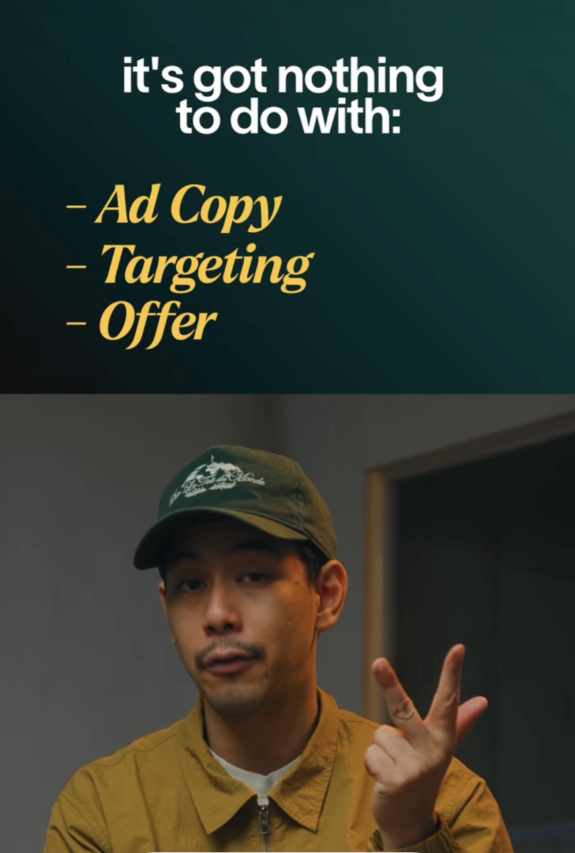

Here's the real problem —
Dead stop after 'real problem.' Let the pause do the work before moving on.

THE PROBLEM
This industry has a name problem. Not a demand problem.
Use Broll of Other Articles defaming reverse Reference this editing style with video example

REFERENCE TO BROLL RM

ON SCREEN: Layer in articles in the links below displaying the headlines/copy of all the media trying to defame this product. Use the full screen if needed to flash as many different screenshots as possible

Think about it.
Consumer debt is at an all-time high.
Retirees are battling rising costs on fixed income.
And homeowners 62 and older are sitting on the largest concentration of tappable home equity in the country.
The demand is there.
The need is real.
So why aren't sales exploding?
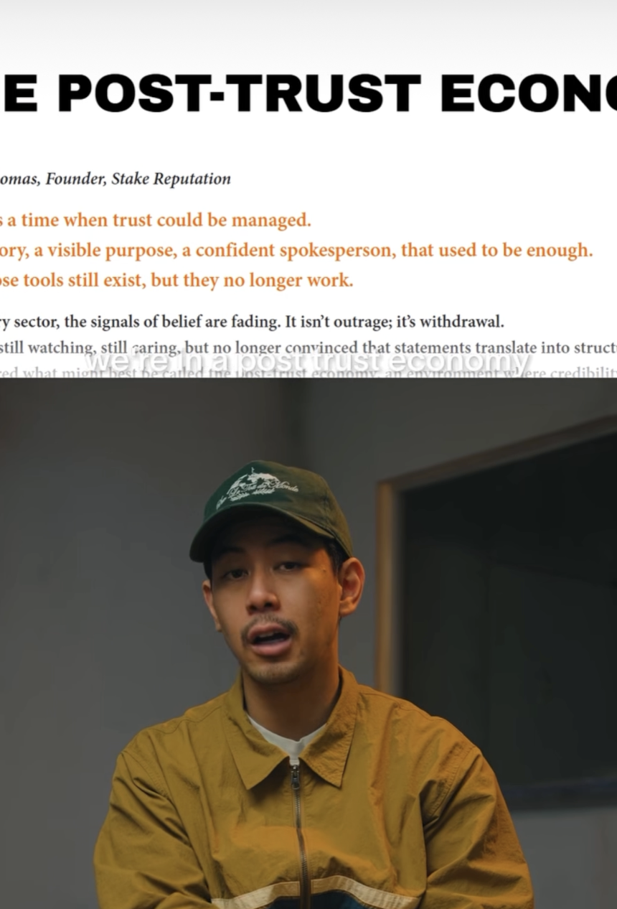
THE FAILED SOLUTION
Most loan officers who've tried marketing already know what happens.
Expensive leads.
Skeptical prospects.
People who won't pick up the phone.
So they write it off.
Marketing doesn't work. Rates are too high. The timing's not right.
And they fall back on what's familiar.
Past clients. Realtors. Financial advisors.
A referral pipeline they don't control and can't scale.
ON SCREEN: "Expensive. Skeptical. Won't pick up." — three words, sequential on screen
Measured pace. Each line lands before the next one starts.
THE INSIGHT
Here's what nobody talks about.
The marketing that's failing isn't failing because the channel is broken.
It's failing because it's targeting the wrong people with the wrong message.
Every homeowner in this market falls into one of two buckets.
They've never heard of this product.
Or they heard something about it once, decided it was a scam, and never thought about it again.
ON SCREEN: "Never heard of it." / "Think it's a scam." — two clean labels, split or sequential
The entire industry has been marketing to the 2% who already know what a reverse mortgage is.
The other 98% have never heard a version of this product that made sense to them.
That's not a demand problem.
That's an education gap.
And it's the biggest untapped opportunity in the mortgage industry right now.
ON SCREEN: "98% education gap" — hold on screen
Pause after 'That's an education gap.' The 2% vs 98% contrast is your strongest insight moment.
THE MECHANISM TEASE
The LOs closing consistent volume right now aren't better closers.
They're not in better markets.
They solved a different problem.
They stopped marketing the product.
And started marketing the problem it solves.
By the time a homeowner gets on a call with them —
the objections are already gone.
The education already happened.
The LO just has to close.
ON SCREEN: "Before the first call is ever made"
This is the turn. Tone shifts from diagnostic to aspirational. Slight lean forward if natural.

PROOF
We built that system.
Exclusively for reverse mortgage loan officers.
Toby averages five to eight funded deals a month on two thousand dollars in ad spend.
Scott closed two deals in his first thirty days.
Same market. Same rates. Different approach.
ON SCREEN: Client names + results as plain text on screen — no graphics needed
Drop proof like a fact, not a testimonial. 'Same market. Same rates.' kills the objection before it forms.

CTA
If you want to see exactly how this works —
and whether it makes sense for your business —
click the link below.
We'll walk you through the whole thing.
Calm and direct. No urgency language. Same peer-to-peer tone as the rest of the script.

Tactical Offer
Using Perspective’s Style of

Agency Myth Revised
[HOOK — first 3 seconds]
"The reason your last agency failed you had nothing to do with Facebook ads."
If you're a reverse mortgage loan officer who's been burned by an agency before — you need to hear this.

[BODY]
Let's be honest. 90% of loan officers in the reverse space are still living off referrals — and I'm not here to tell you that's killing your business. You already know that.
The real reason most LOs never make the jump to direct-to-consumer marketing isn't fear. It's because this industry has been burned. Badly.
You spent thousands of dollars. Leads hit your CRM. Nobody picked up. Half of them didn't qualify. The other half didn't even know they clicked on an ad. And you walked away thinking — "marketing just doesn't work for this niche."
I don't blame you. That conclusion makes complete sense given what you experienced.
But here's what actually happened: you didn't have a marketing problem. You had a partner problem.
Here's the thing — even if you took our exact ads, copied them word for word, and ran them yourself tomorrow... it still wouldn't work.
Because the world has changed. The way people buy, the way leads behave, the way attention moves — it's completely different than it was 10 years ago. An ad is just a door. What happens after someone walks through it is where deals actually get made or lost.
We don't get the results we get solely because of our ads. The ads are just the beginning. What's actually doing the work is everything behind them — the funnel that pre-educates the lead before they ever opt in, the callers who pick up the phone within minutes of someone raising their hand, the follow-up sequences that stay on a prospect for weeks without you lifting a finger, and the AI running in the background at 11pm when someone finally responds.
Most agencies hand you a list of names and disappear. And maybe slap together a basic drip campaign that was written by a AI prompt. That's not a system. That's a starting point with no finish line.
And there's no silver bullet that makes this work. There's only a system — the right ad, the right message, the right follow-up, the right qualification process — all running together. When those pieces hit in congruence, the math takes over.
That's what we build at Waiz Media. Not leads. An acquisition engine — built exclusively for reverse mortgage loan officers.
[CTA]
If you've been burned before and you're skeptical — good. That means you'll actually pay attention to what we do differently. Click below and let's show you the system.
HOOK (3–5 sec)
"Let's be honest. 90% of loan officers in the reverse space are still living off referrals — and I'm not here to tell you that's killing your business. You already know that."

PAIN (7–10 sec)
"The real reason most LOs never make the jump to direct-to-consumer isn't fear. It's because this industry has been burned. Badly.
You spent thousands of dollars. Leads hit your CRM. Nobody picked up. Half didn't qualify. The other half didn't even know they clicked on an ad.
And you walked away thinking — 'marketing just doesn't work for this niche.'
I don't blame you. That conclusion makes complete sense given what you experienced.
And honestly? Every time I hear it — it pisses me off. Because those agencies make it harder for the ones actually doing the work to earn your trust."

WHY IT ACTUALLY FAILED (15–20 sec)
"But here's what actually happened. You didn't have a marketing problem. You had a partner problem.
And here's exactly why it failed.
The agency you worked with wasn't built for this niche. They were a generalist. DSCR, HELOC, commercial, purchase — didn't matter. If you had a budget, they had a proposal.
And here's the problem with that. You cannot be great at everything.
The reverse mortgage borrower is a completely different human being than a first-time homebuyer. The stigma is different. The psychology is different. The objections are different. The entire marketing approach has to be different.
So what did they do? They took the same stock image ad they run for every other product, swapped in the words 'reverse mortgage,' and pointed it at anyone over 62 with a pulse.
No understanding of the stigma. No understanding of why leading with the words 'reverse mortgage' triggers every misconception the prospect already has before the conversation even starts. No understanding that this demographic doesn't respond to 'apply now' — they respond to education, to trust, to someone speaking directly to their retirement problem.
So the leads that came in were cold, confused, and completely unprepared. They clicked on something that didn't explain what they were getting into. And when someone finally called them — if they even called fast enough — the prospect had no idea who was on the phone or why.
That's not a lead quality problem. That's a messaging problem that started at the ad level and poisoned everything downstream.
And then — the agency stopped there. No callers. No real follow-up. Maybe a basic drip campaign written by a ChatGPT prompt. Just a CRM full of names and a retainer invoice at the end of the month.
That's not a system. That's a starting point with no finish line."

WHY BETTER ADS ALONE WON'T FIX IT (15–20 sec)
"And here's the part that most people get wrong when they try again.
They think the fix is better ads.
It's not.
Even if you took our exact ads — copied them word for word — and ran them yourself tomorrow, it still wouldn't work.
Because the world has changed. The way people buy, the way leads behave, the way attention moves — it's completely different than it was ten years ago.
Spam blockers are more advanced. People screen calls differently. The timing, the message, the channel, the follow-up cadence — all of it has shifted. It used to be simple. You called, they picked up, you talked. That world is gone.
Now there's a literal science to it. And we've spent years figuring it out — testing hundreds of funnels, scripts, text sequences, call timing strategies — to find what actually gets reverse mortgage prospects to pick up, respond, and show up.
An ad is just a door. What happens after someone walks through it is where deals get made or lost.
We don't get the results we get because of our ads. The ads are just the beginning. What's actually doing the work is everything behind them — the funnel that pre-educates the lead before they ever opt in, the callers who pick up the phone within minutes of someone raising their hand, the follow-up sequences that stay on a prospect for weeks without you lifting a finger, and the AI running in the background at 11pm when someone finally responds.
Most agencies hand you a list and disappear. We hand you a calendar full of booked appointments.
There is no silver bullet. There's only a million gold BBs — the ad, the funnel, the caller, the follow-up, the AI — all hitting in congruence. When every piece is built for this niche and running together, the math takes over."

WHAT WE BUILT (10–15 sec)
"We're Waiz Media. And we work exclusively with reverse mortgage loan officers. This is the only niche we operate in.
We are not a marketing agency that runs your ads and emails you a report at the end of the month. That's not what this is.
What we built is the entire front end of your business. The ads, the funnel, the follow-up science, the live setters, the booked appointments — all of it, done for you, running in the background while you focus on closing.
Most agencies are a cost. This is infrastructure.
And infrastructure compounds. The longer it runs, the more data it has, the better it performs, the lower your cost per appointment gets."

CTA
"Your skepticism is valid. Your past experience taught you to be careful — and you should be.
But don't let one bad agency — or five bad agencies — stop you from finding the right partner.
We built this for the loan officer who has been burned before. We have nothing to hide. And everything to prove.
Click below and let's show you the system."

Agency Myth

Myth About Agencies - They’re all bad

Mortgage Brokers who’re in the Reverse space

Pointing the obvious

90% of this industry is comprised of loan officers who are quite frankly relying on their referrals. This is not going to be some other video that tells you, "Hey, referrals are killing your business." You already know that. The reality is that the reason that most LOs don't take that big jump to direct-to-consumer and investing in their business is because the industry has been burnt by shitty marketing agencies and lead companies.
As you spent thousands of dollars to end up getting a bunch of leads sent to your CRM that either
- Didn’t pick up the phone
- Didn’t qualify
- Didn’t even know who you were
Which left you questioning on whether it’s even worth ever taking risks in the business again, or “the market is bad” or "Marketing doesn’t work”
And i don’t blame you for thinking that. But heres the thing, there is a huge demand for Reverse mortgages right now. People in the US are in dire need for financial relief and theres more tappable home equity in this demographic than before. And you can’t expect to tap into these opportunities by your referral partners to send you them all nor should you expect some marketing agency to run a ad
What most marketing agencies or people don’t realize about this industry is that theres such thing as a silver bullet when building a lead generation system, only a bunch of gold bb’s that when hits all in congruence.

Tab 7
SPEAKER: "Most loan officers I talk to are working twice as hard as they were three years ago."
🖥️ WORKING TWICE AS HARD
One beat.
SPEAKER: "And making half the money."
🖥️ MAKING HALF THE MONEY (red)
Beat. Let it land.
SPEAKER: "Same license. Same skills. Same market."
🖥️ SAME LICENSE / SAME SKILLS / SAME MARKET
SPEAKER: "The only difference between them and the LOs I work with who are closing $20, $30, $40K months?"
🖥️ $20K / $30K / $40K MONTHS
Pause. Direct eye contact.
SPEAKER: "They stopped competing in a market that's designed to grind them down."
🖥️ STOPPED COMPETING
Slight lean in.
SPEAKER: "And moved into one that almost nobody else is in."
🖥️ ALMOST NOBODY ELSE IS IN
Beat.
SPEAKER: "It's not a secret. It's just reverse mortgages."
🖥️ REVERSE / MORTGAGES (bold, centered, held 2 seconds)

